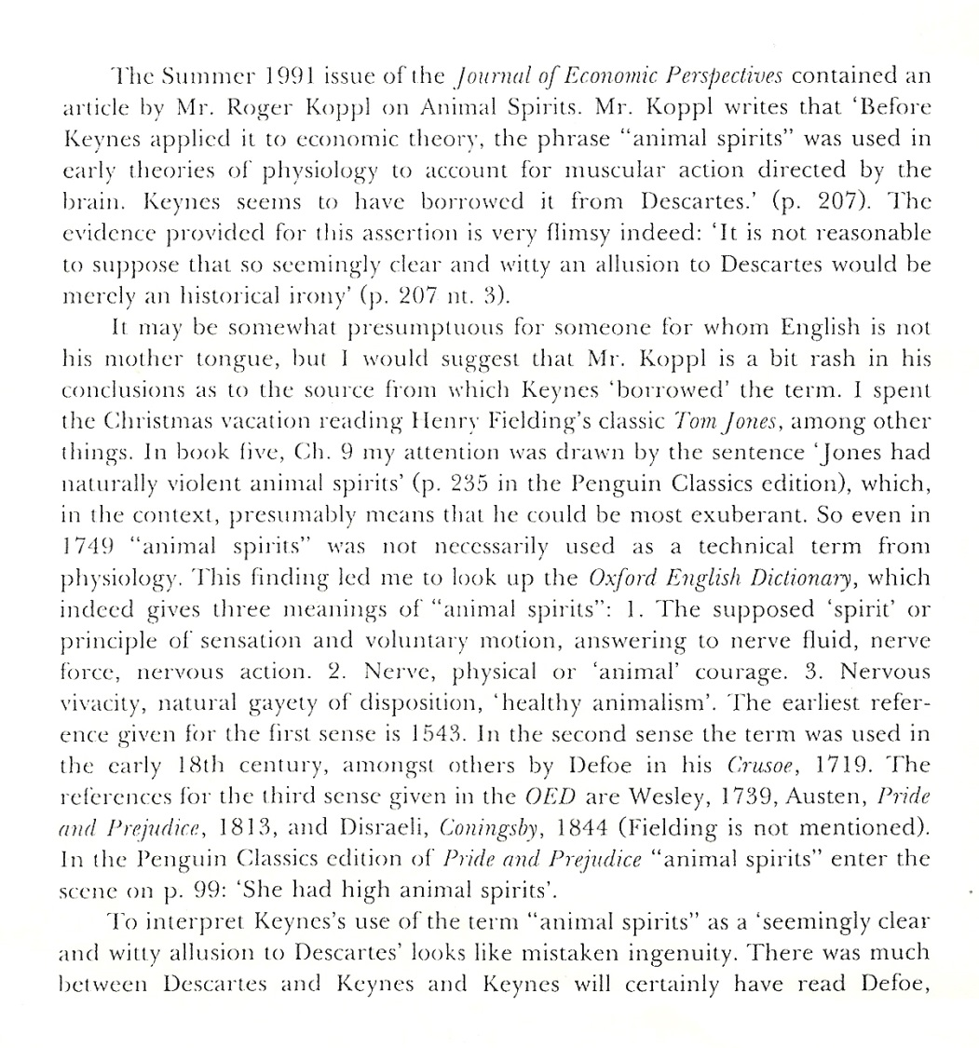

From:
Correspondence, Journal of Economic Perspectives, 6:3, 1992, pp. 209-210.

